**Practical 4: Demonstrate to SELECT with clauses.**

**Student Name :Rohit Narendra Bodade Div: A BATCH no: B1**

**Roll no:20 Date:23-2-2024**

use rohit

CREATE TABLE student_info(

Student_id int,

Student_name varchar(89),

address varchar(89),

city varchar(80),

Dob date,

age int,

);

INSERT INTO student_info(Student_id ,Student_name ,address ,city ,Dob ,age)

values(1,'yash baviskar','gangaram plot','jalgaon','10/4/2005','18');

INSERT INTO student_info(Student_id ,Student_name ,address ,city ,Dob ,age)

values(2,'ashish patil','lalbag plot','jalgaon','5/8/2005','18');

INSERT INTO student_info(Student_id ,Student_name ,address ,city ,Dob ,age)

values(3,'raghav baviskar',' Neharu Nagar','jalgaon','9/12/2005','18');

INSERT INTO student_info(Student_id ,Student_name ,address ,city ,Dob ,age)

values(4,'mahesh patil',' ayodhy Nagar','jalgaon','5/2/2005','18');

INSERT INTO student_info(Student_id ,Student_name ,address ,city ,Dob ,age)

values(5,'hitesh chaudhari','patil nagar','jalgaon','6/6/2005','18');

select * from student_info;

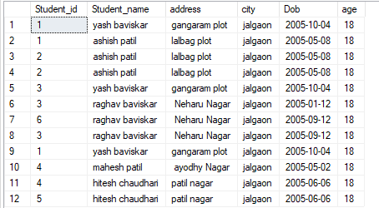

* Order By
* **Ascending Order**

Select * From student_info Order By Student_name;

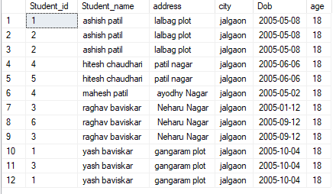

* Decending Order

Select * From student_info Order By Student_name DESC;

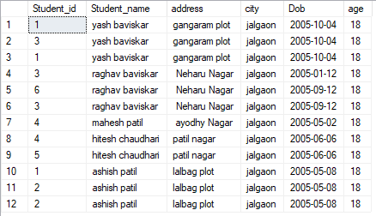

* Where Clauses

Select * From student_info Where(age>=19);

